The purpose of this lab is to practice using for loops, conditionals, methods, and variables. Your sketch will be created in a window that is 720 x 720. You can choose any color for the background.

**Step 1:** Complete the drawGrid() method. This method, when called, will transform the screen into a grid of squares that is 10 x 10. You can choose whatever color you want for the stroke of the lines, but make sure it stands out against your background color. Call the drawGrid() method in draw() so the grid will show up. Your screen should something like this:

 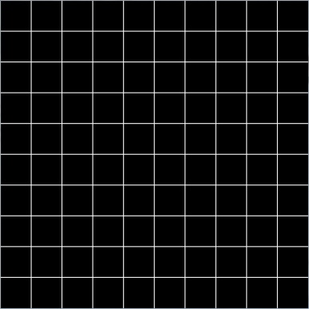

Before call to drawGrid() After call to drawGrid()

**Step 2:** Complete the highlightSquare() method. This method will “highlight” the square the mouse is currently covering. Make sure to call the method after you call drawGrid() method in draw().

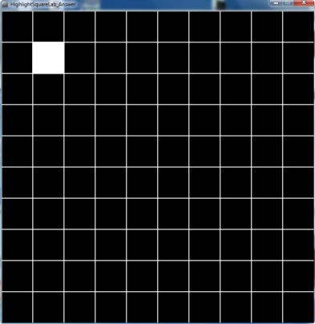 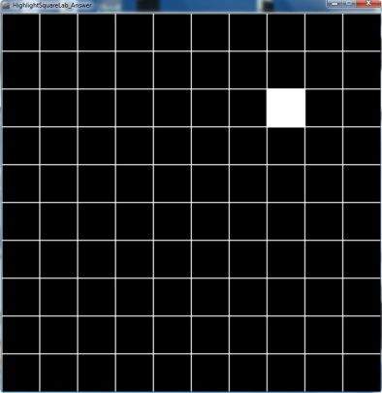

The method itself will not require you to use any knowledge that we have not discussed already in class. Fill out the following chart to help you solve the puzzle.

int sizeOfSquare = ________; // length of one of the sides of a square in the grid

|  |  |  |
| --- | --- | --- |
| **x** | **x / sizeOfSquare** | **x / sizeOfSquare * _________** |
| 20 | 0 | 0 |
| 70 | 0 | 0 |
| 72 | 1 | 72 |
| 160 | 2 | 144 |
| 288 | 4 | 288 |
| 300 | 4 | 288 |
| 370 | 5 | 360 |

**Step 3:** Add a boolean variable to the top of your program. This will be used to turn off/on the call to the background() method in draw(). Initialize the variable to true. Add an if statement so that background only gets called if this boolean variable is true. Use the mouseClicked() method to switch the boolean between true and false.